
STUDENT NAME: SHEIKH FARDOSA JIBRIL
ADMISSION NUMBER: BSCCS/2024/54679
COURSE: COMPUTER SCIENCE
UNIT CODE: BIT 3208
UNIT NAME: ADVANCED WEB DESIGN AND DEVELOPMENT
LECTURERS NAME: NYORO MICHAEL
SEMESTER: 3,2

PROJECT DETAILS
PROJECT TITLE: Smart Task & Study Management System
SELECTED TECHNOLOGIES:
HTML
CSS
JAVA SCRIPT
PHP
MYSQL
XAMPP

TABLE OF CONTENTS
Contents
WEEK 1: LOCAL ENVIRONMENT SETUP 3
INSTALLATION AND TESTING OF LOCAL ENVIRONMENT SEETUP 3
Fig 1: installation of XAMPP 4
Fig 2: shows Apache and mysql running 5
Fig 3: localhost test page 5
5
Fig 4: hello world test 5
Fig 5: database connection test 6
WEEK 2 : WIREFRAMES AND GUI DESIGN 6
Title : user interface planning and system design 6
Fig 6: Hand drawn wireframe showing login page 7
Fig 7: showing dashboard layout design 8
Fig 8: Mobile view mockup 8
Fig 9: shows the login page in canva 9
WEEK 3: JAVASCRIPT AND PHP BASICS 11
TITLE: Frontend Interactions And Backend Foundations 11
Week 4 : 14
server side components and backend development functions 14
Fig 17: shows login.php 14
Fig 13:shows database to enter information 15
Fig 15: showing sample of the dashboard 16
Week 5: 17
Database components and crude operations 17

WEEK 1: LOCAL ENVIRONMENT SETUP

INSTALLATION AND TESTING OF LOCAL ENVIRONMENT SEETUP

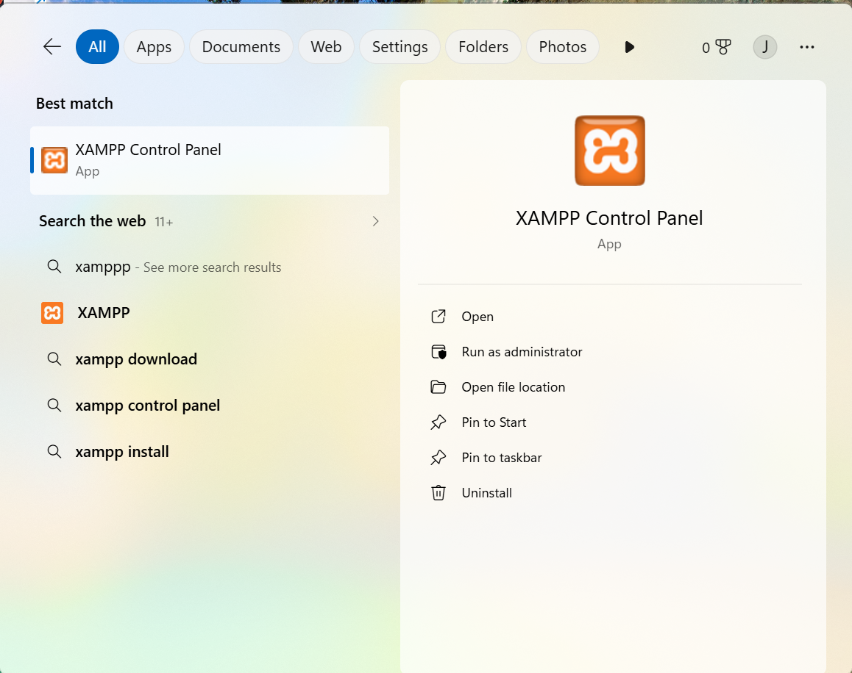

Fig 1: installation of XAMPP

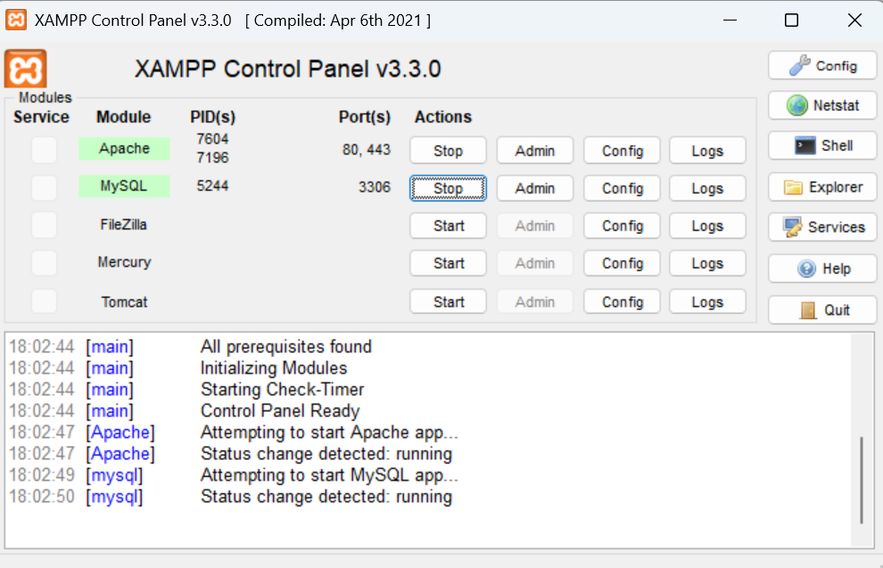

Fig 2: shows Apache and mysql running

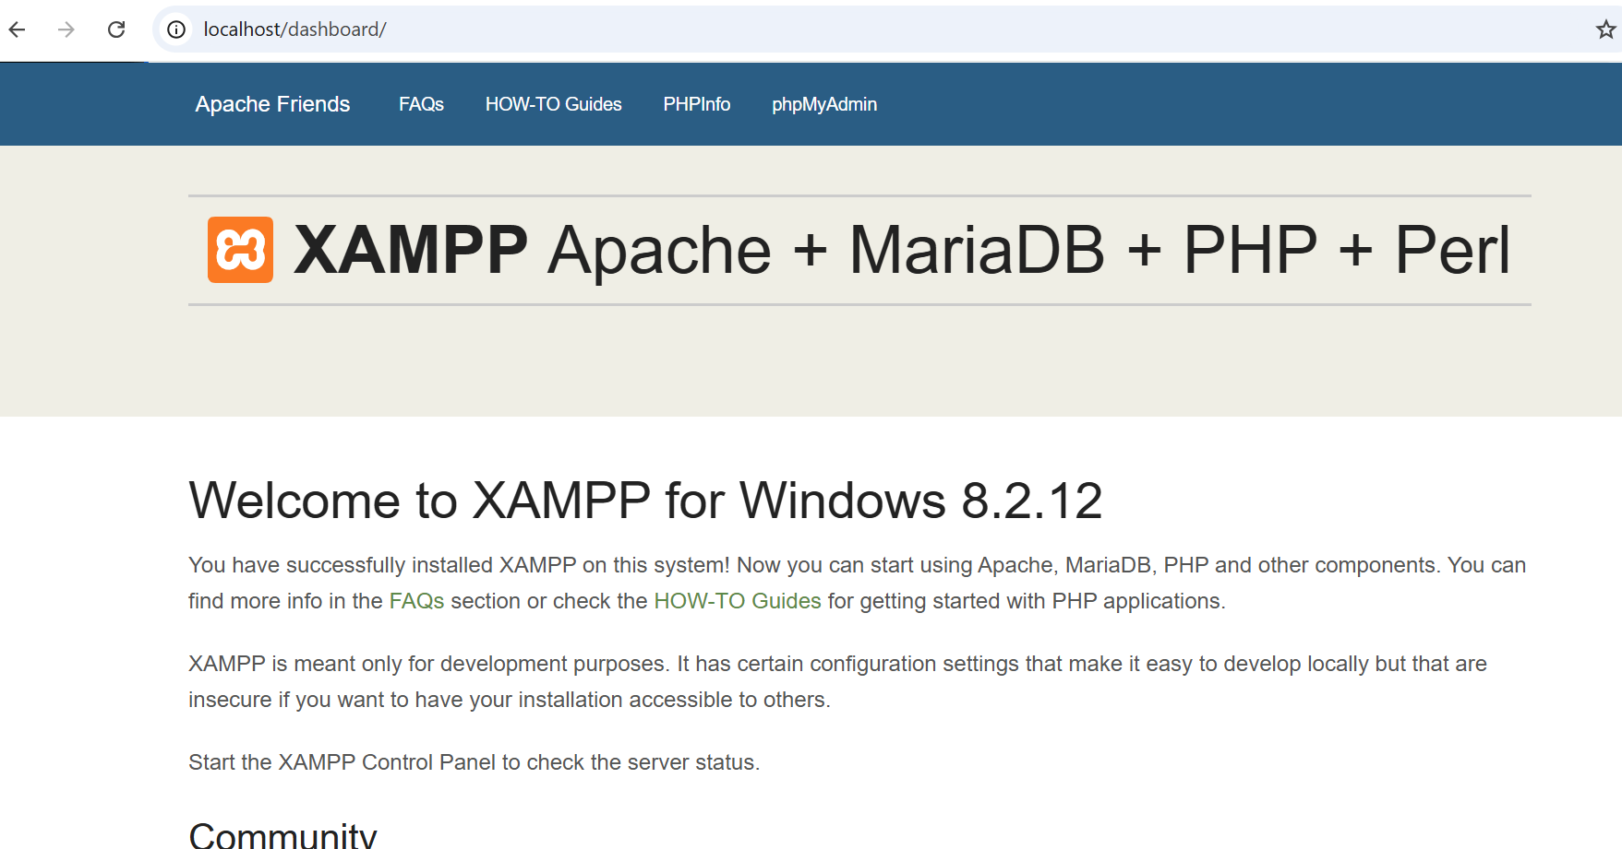

Fig 3: localhost test page

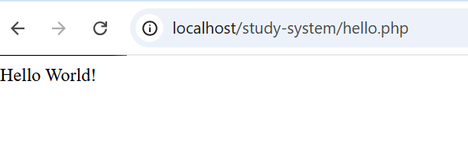

Fig 4: hello world test

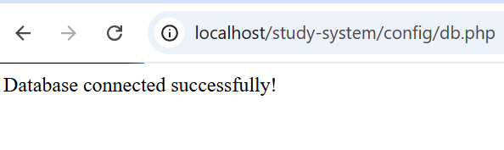

Fig 5: database connection test

STUDENT REFLECTION
The installation process involved setting up XAMPP to enable a local server environment for PHP and MySQL. A “Hello World” test confirmed PHP was running correctly through localhost. A database connection test using phpMyAdmin verified successful communication between PHP and MySQL, demonstrating how web applications interact with backend servers and databases.

WEEK 2 : WIREFRAMES AND GUI DESIGN

Title : user interface planning and system design

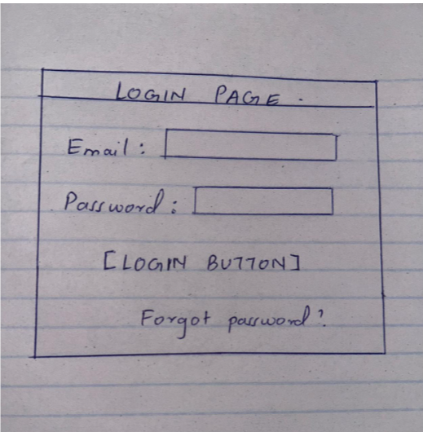

Fig 6: Hand drawn wireframe showing login page

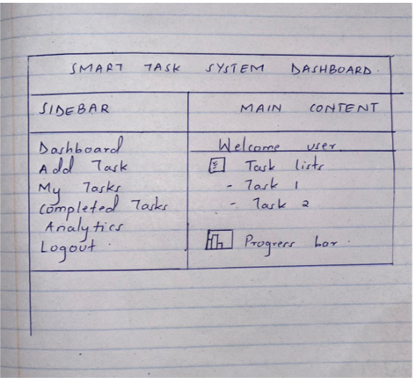

Fig 7: showing dashboard layout design
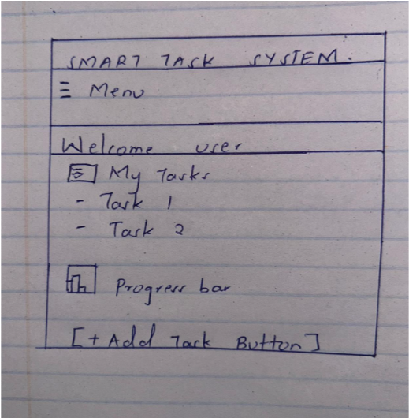

Fig 8: Mobile view mockup

COLOR THEME AND NAVIGATION STRUCTURE
Colour theme
Primary color : white
Secondary color : black
Accent color: red
Background color: light grey
Text color : black
Navigation structure
Sidebar navigation for desktop
Top menu for mobile
Links:
Dashboard
Add task
Completed task
Analytics
logout
GUI PROTOTYPE IN CANVA
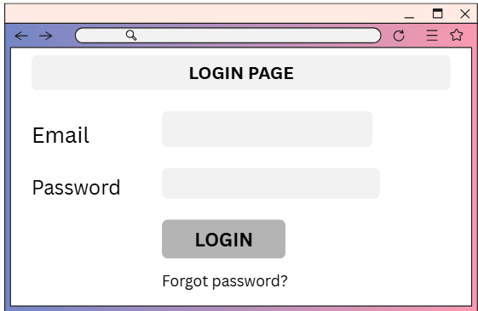

Fig 9: shows the login page in canva

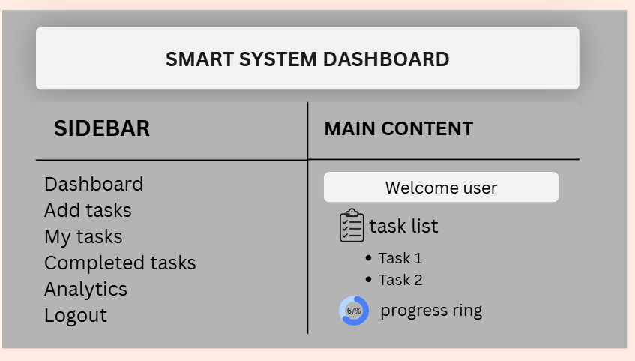
Fig 10: shows the dashboard made in canva

STUDENT REFLECTION
The design was selected to provide a simple, organized, and user-friendly interface for managing study tasks and monitoring productivity. User experience was considered by creating clear navigation, readable layouts, and responsive mobile views. The navigation flow was planned to allow users to move easily between the dashboard, task management, analytics, and account functions with minimal effort. The system is intended for students who need an efficient way to organize assignments, track progress, and manage their study schedules. The layout also allows for future expansion as additional features and modules are introduced.

WEEK 3: JAVASCRIPT AND PHP BASICS

TITLE: Frontend Interactions And Backend Foundations
Javascript form validation
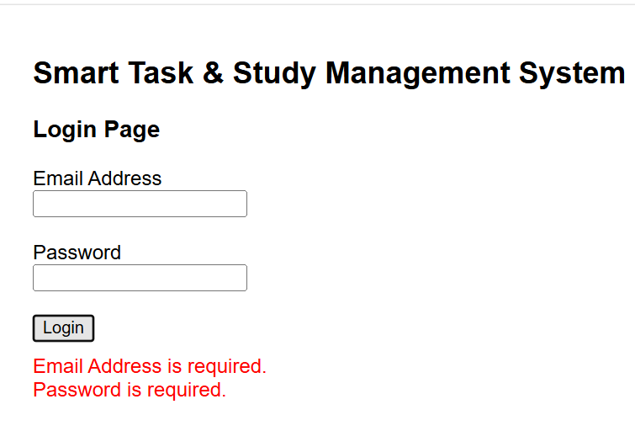
Fig 10: Javascript form validation

Password strength checker
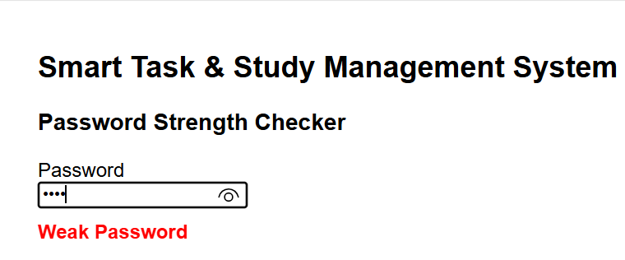
Fig 11: password strength checker using javascript

Php syntax practise
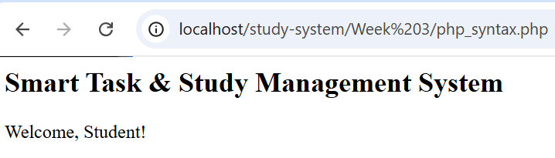
Fig 12: show php running correctly in XAMPP

Database connection script
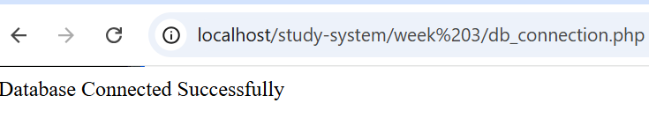
Fig 13: php successfully connected to mysql

Dynamic user input handling
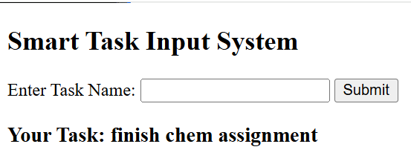
Fig 14: system takes user input and dynamically displays it using php

Student evaluation
Week 3 focused on practical implementation of core web development concepts using JavaScript, PHP, and MySQL. JavaScript was used to perform form validation and password strength checking to improve user input quality and security. PHP was applied to understand basic syntax and server-side processing, including handling user input dynamically. A database connection script was also developed to demonstrate communication between the application and MySQL. This phase helped reinforce understanding of how frontend and backend technologies work together in building interactive and data-driven web systems.

Week 4 :

server side components and backend development functions

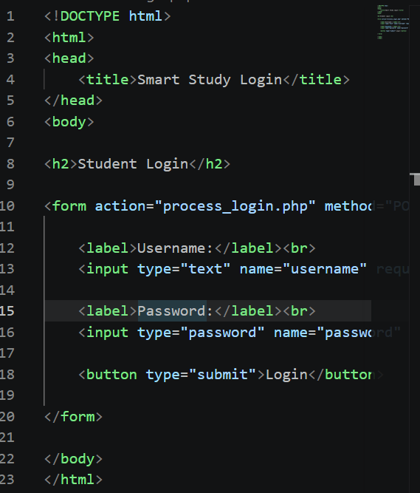

Fig 17: shows login.php

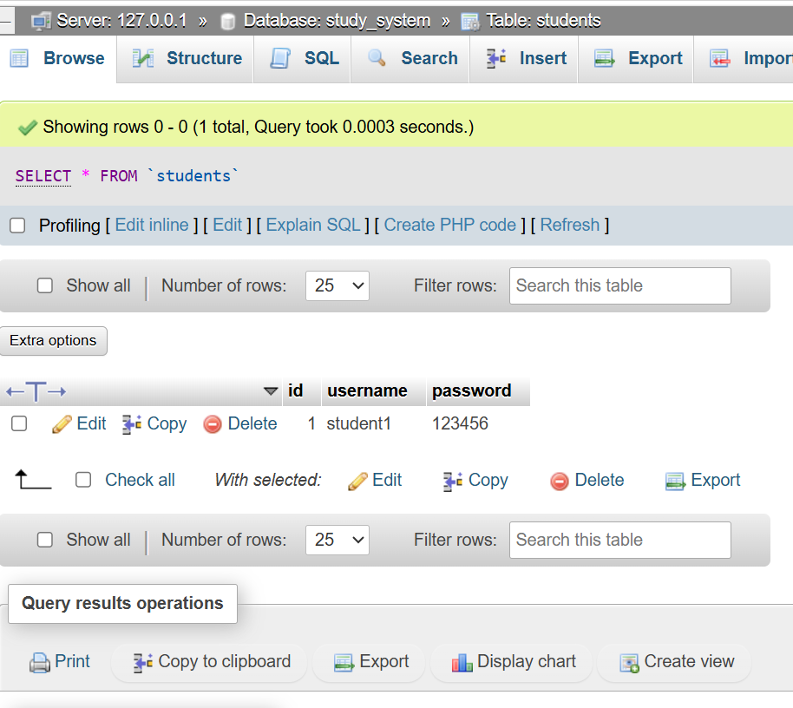

Fig 13:shows database to enter information

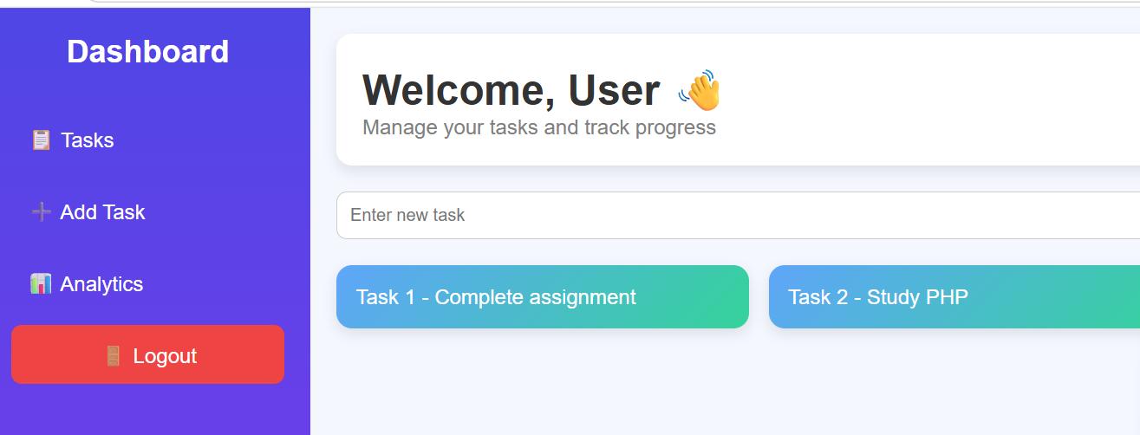

Fig 15: showing sample of the dashboard

Student evaluation
During Week 4, I developed a simple Smart Study and Management System using PHP and MySQL. The main focus was to understand how frontend forms communicate with backend scripts and how data is processed on the server side.The system includes a basic login module, a database connection, and a dashboard page. I created a MySQL database named study system with a students table that stores usernames and passwords. This helped me understand how data is stored and retrieved from a database using SQL query

Week 5:

Database components and crude operations

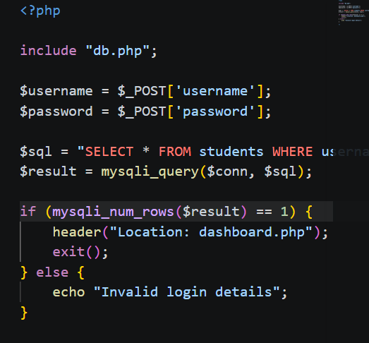
Srudent evaluation

